**Processed Gas Valuation Analysis Tool User Guide**

Thomas Manuel Ortiz, Ph.D., P.E.

Last Updated on January 17, 2019

**Overview**

The GLO Processed Gas Valuation Analysis tool allows auditors to verify the quantity and value of all products available from a raw natural gas stream that is produced from a State lease or pooled unit. The tool’s design is based on work done by Matthew T. Scott, P.E., and encapsulates the underlying engineering science into a suite of Python scripts that are stored securely on the GLO network. The Excel tool interface relies on these scripts to calculate all results, and it must be run on the network.

**Installation and Access**

The tool is accessed and executed from O:\AUDIT_TOOLS directory.

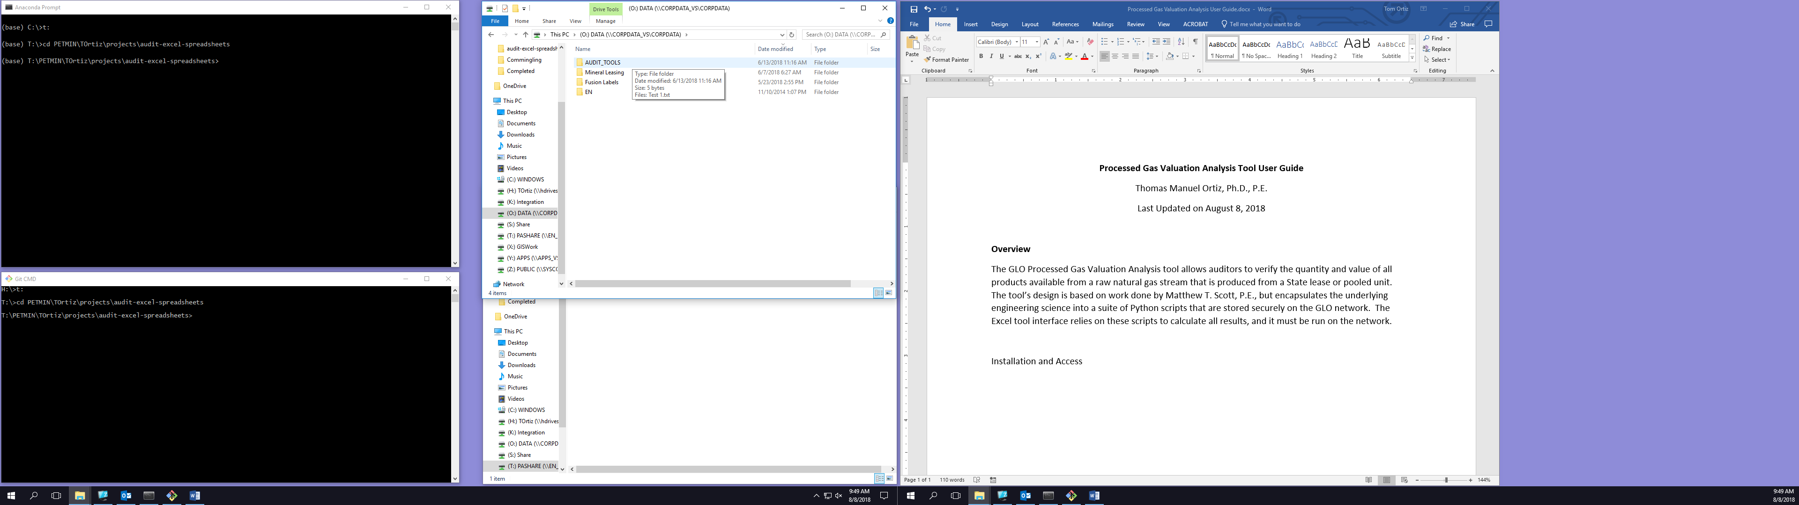

Inside this directory you will see the following items: a shortcut to a macro-enabled Excel spreadsheet, and two directories. One of the directories is hidden, and if you do not have Show Hidden Files enabled on your computer, you may not see src, which is fine. You will never need to access the src directory.

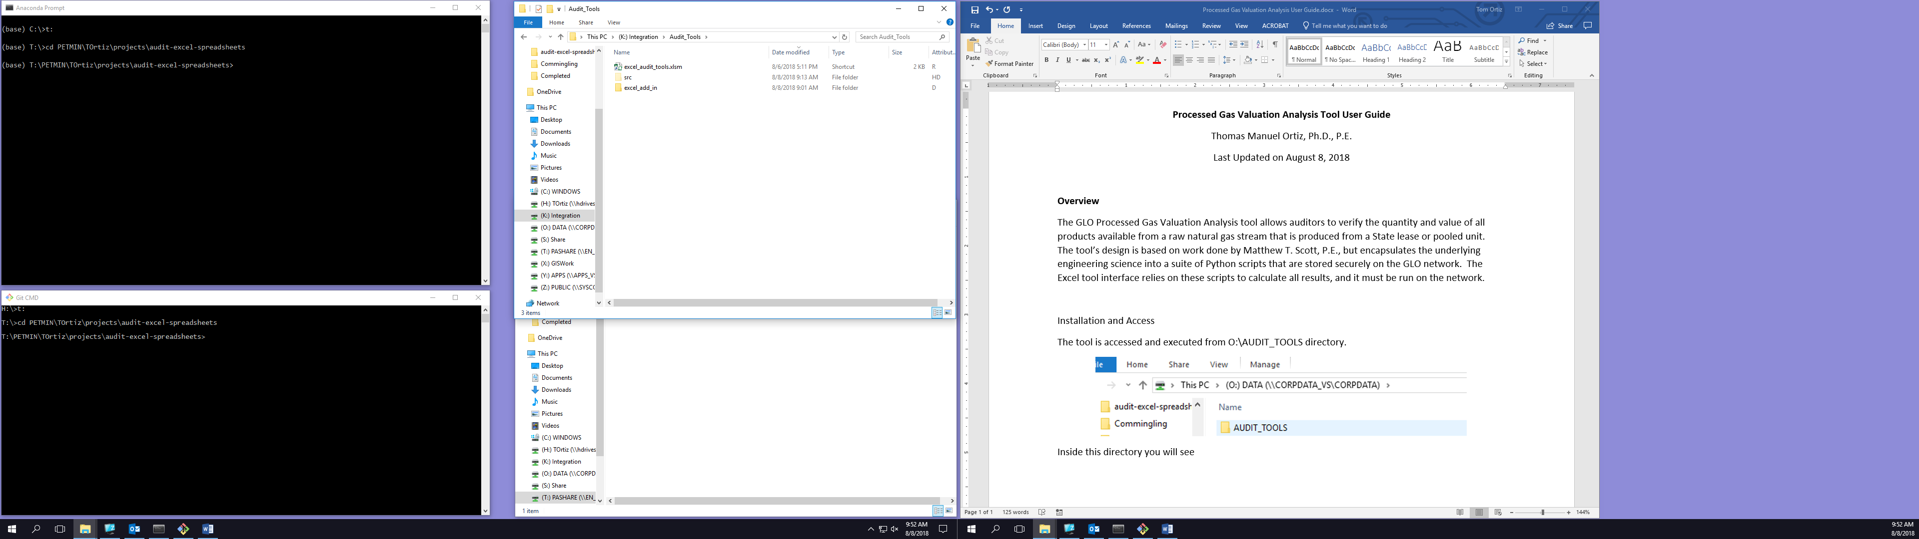

Open Microsoft Excel on your computer, and navigate to the Developer tab.

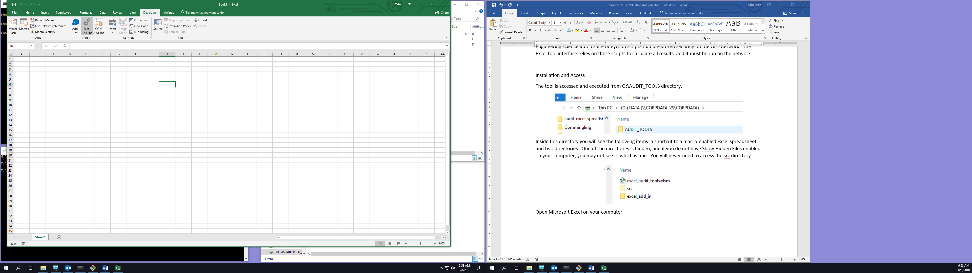

Click on the Excel Add-ins button in the Ribbon. The Add-ins dialog will appear. Click Browse.

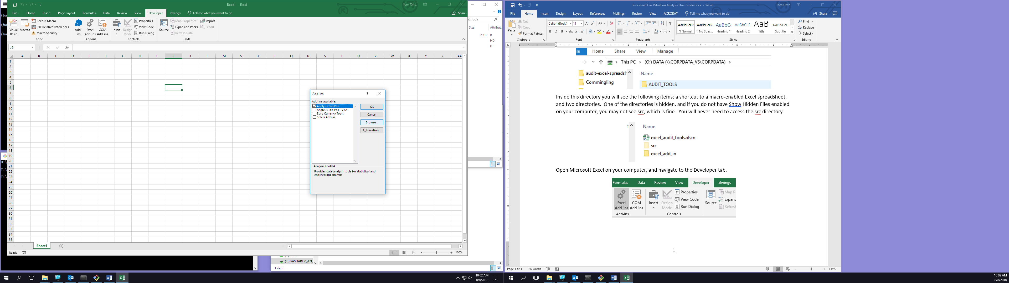

Browse to O:\AUDIT_TOOLS\excel_add_in and choose xlwings.xlam to install the add-in to Excel.

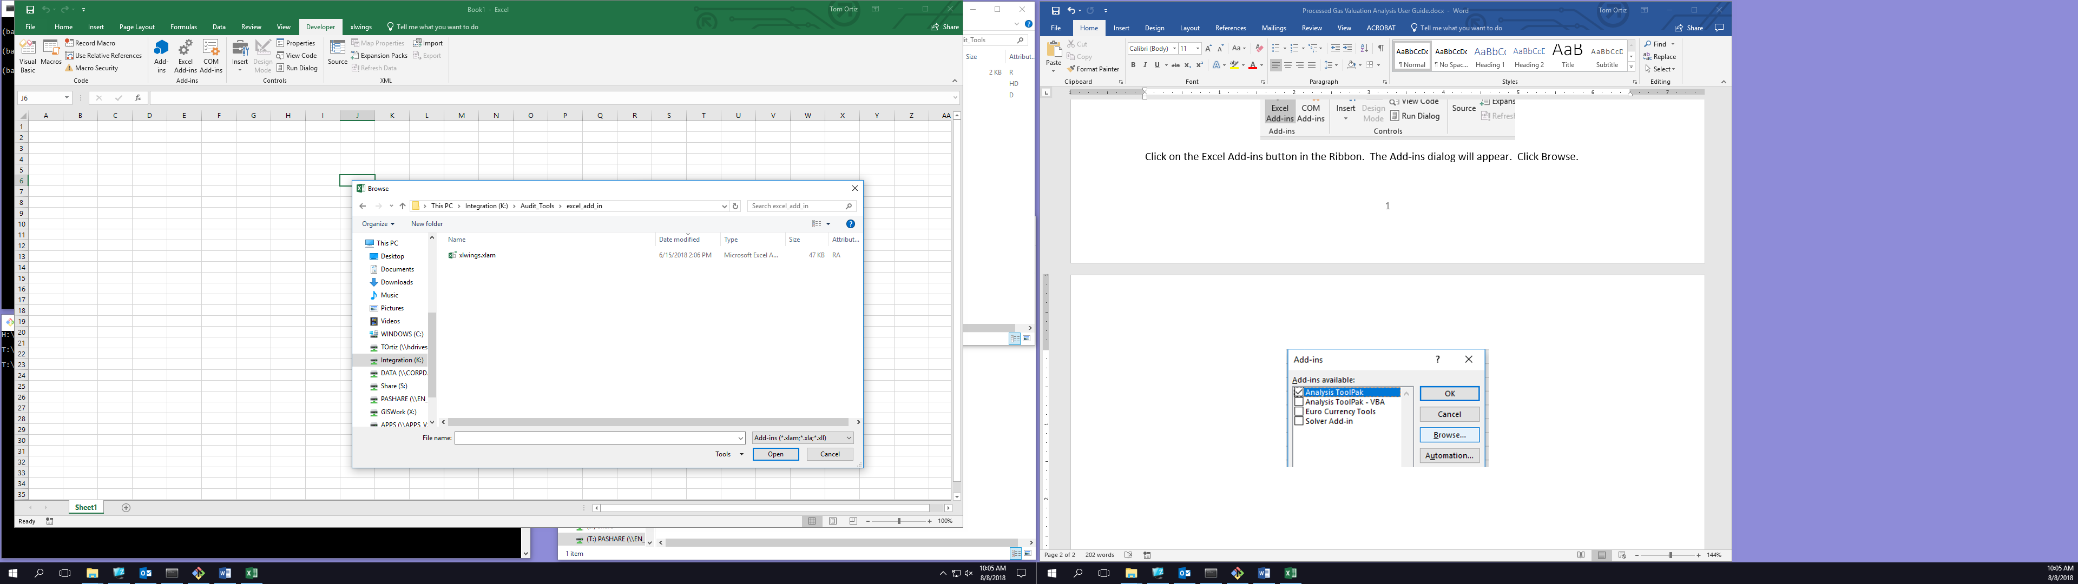

**NOTE:** If you already have a copy of the xlwings add-in installed, you should uninstall it and install the latest version from O:\AUDIT_TOOLS\excel_add_in.

There is nothing else for you to install. You may have to restart Excel to see the new xlwings tab.

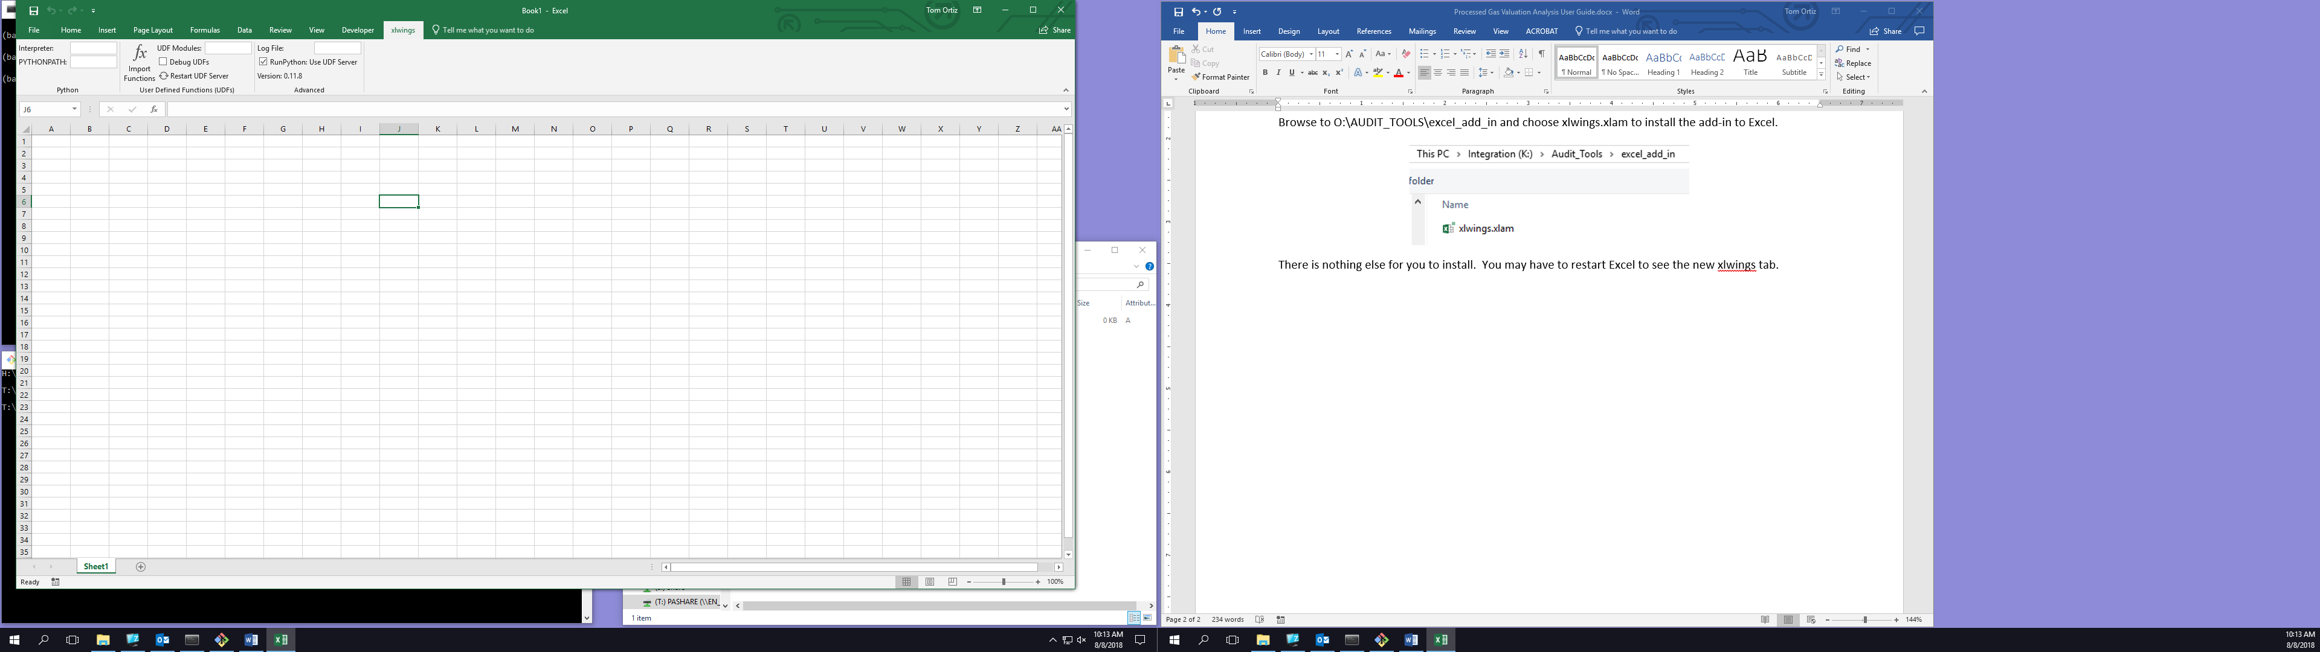

Be sure the xlwings tab is configured exactly as shown above.

Double-click on the shortcut O:\AUDIT_TOOLS\excel_audit_tools.xlsm to open the tool in Excel.



Once the file is open in Excel, navigate to the xlwings tab and click Import Functions.



Once Import Functions finishes running, you are ready to use the tool.

**Entering Input Data**

Administrative information about the lease can be entered at the top of the worksheet. This information is not needed to run the tool, and it may therefore be left blank if desired.

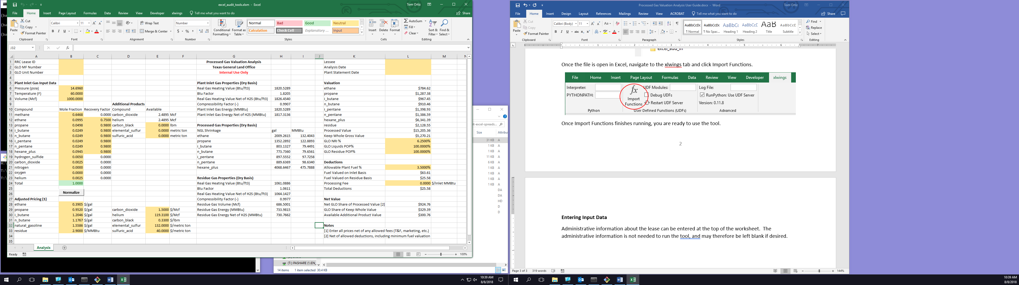

The pressure, temperature, and volume (PVT) data corresponding to the gross lease or unit production must be entered in the following section:

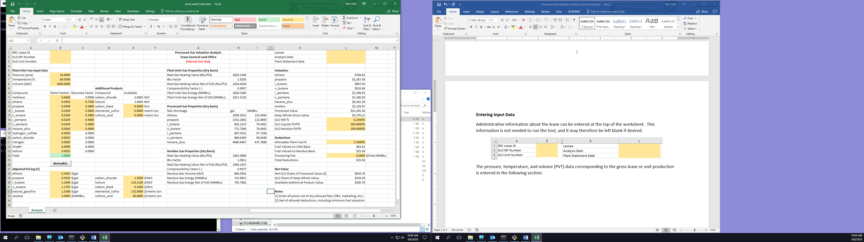

Note the units associated with each input quantity. These input fields must be mutually consistent, i.e. the volume you enter must correspond to the temperature and pressure conditions you enter. For now, the tool will only allow you to enter a temperature of 60 F. This temperature limitation relates to the method currently in place to calculate gas compressibility factors.

You must also enter the gas composition and associated recovery factors before running the tool. You will not be allowed to enter mole fractions that do not fall within the range 0.0 – 1.0, and the tool will check to see if the sum of all mole fractions is equal to 1.0. If it is not, the Total cell will turn red.

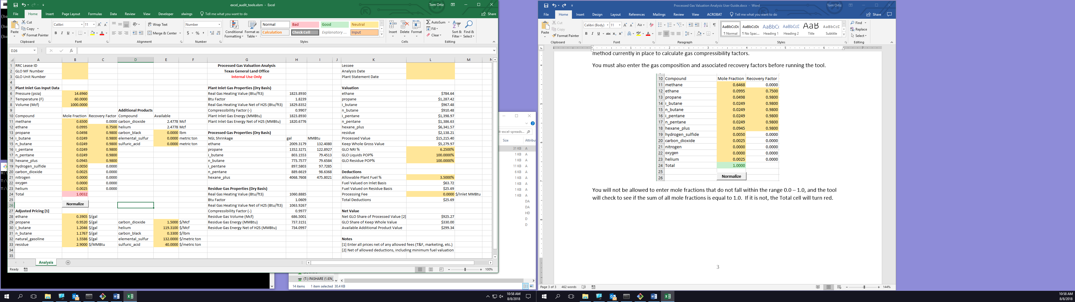

In cases where there is a small imbalance in the mole fraction sum, you may press the Normalize button, which will adjust the mole fractions to make their sum equal to 1.0 and turn the Total cell green.



Note that normalization is not a substitute for gathering the correct gas composition data from lab reports or other authoritative sources. If your gas composition does not match the one shown on the appropriate lab report, then your calculation results will be inaccurate.

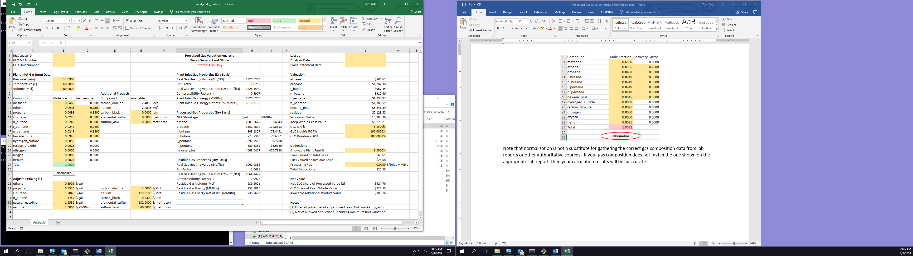

Recovery factors, which must be entered as values in the range 0.0 – 1.0, represent the fraction of theoretical liquid that can be (or is guaranteed by contract to be) extracted by the gas plant from the raw gas stream. The tool will only use recovery factors for ethane, propane, i_butane, n_butane, i_pentane, n_pentane, and hexane_plus.

All prices should be entered net of any and all allowed fees or deductions (e.g. T&F, marketing).

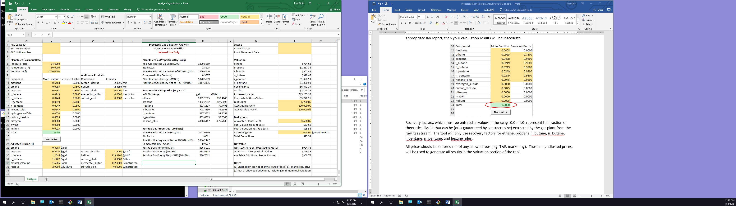

These prices will be used to generate all results in the Valuation section of the tool. GLO shares of the valuation are determined by entering the net revenue interest (NRI) for the lease or unit, the percent of proceeds (POP) percentages **attributable to GLO** for NGLs and residue gas, and the percentage of plant fuel and processing fee (in $ per MMBtu of inlet gas) that may be deducted by the lessee by contract.

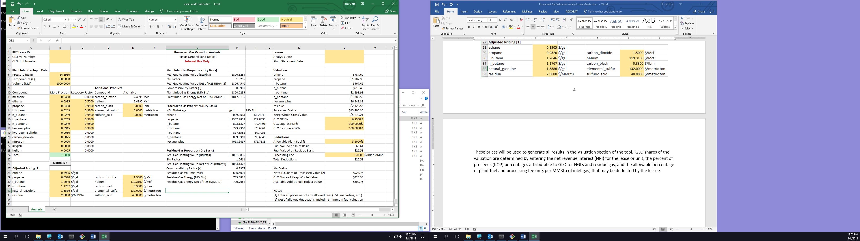

The tool by default includes the lowest fuel value—which will be the value calculated assuming plant fuel is taken from the residue gas stream—in the Total Deductions cell.

Finally, you may input the available amounts of any additional products that are available for extraction and processing by the plant.

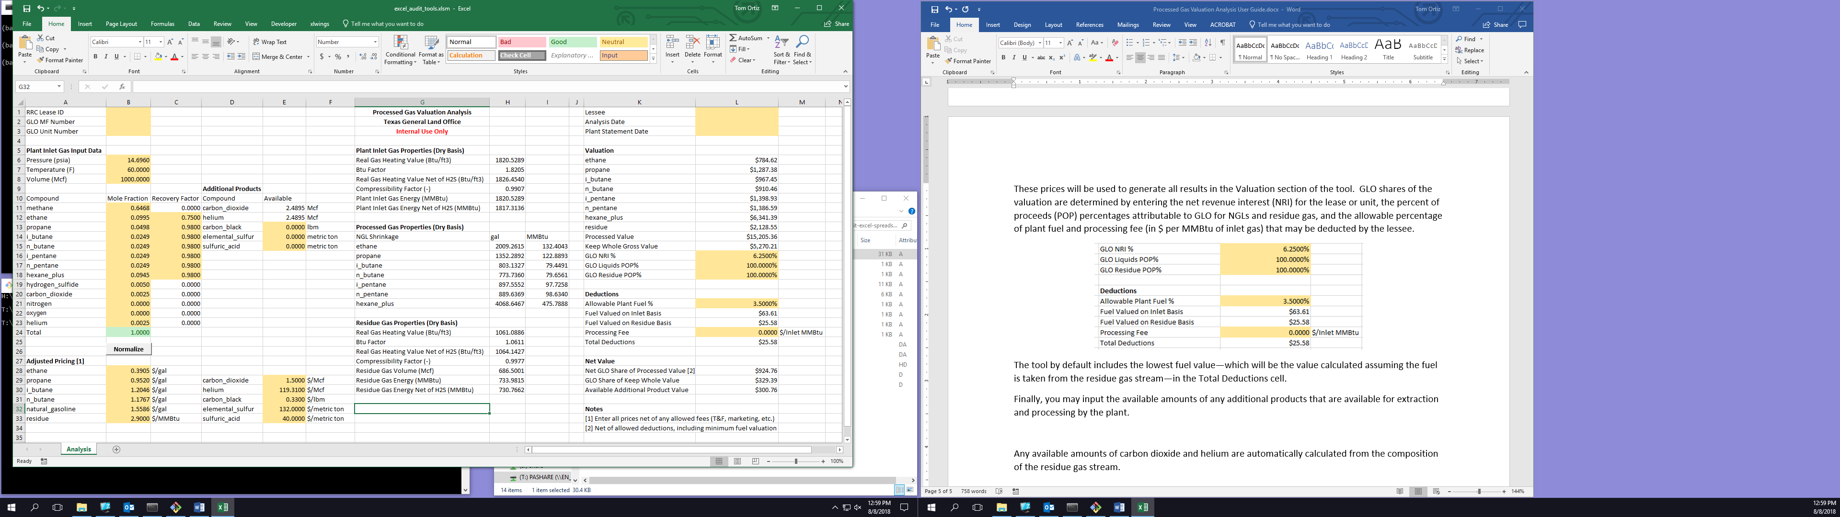

Any available amounts of saleable carbon dioxide and helium are automatically calculated from the composition of the residue gas stream.

**Reviewing and Saving Results**

The plant inlet gas properties calculated by the tool pertain only to the gas volume and composition that correspond to production from the lease being analyzed. As such, they may not match the inlet gas properties on your gas plant settlement statement. That is OK. These properties allow you to review the quality of the State’s gas in isolation from other commingled gas sources.

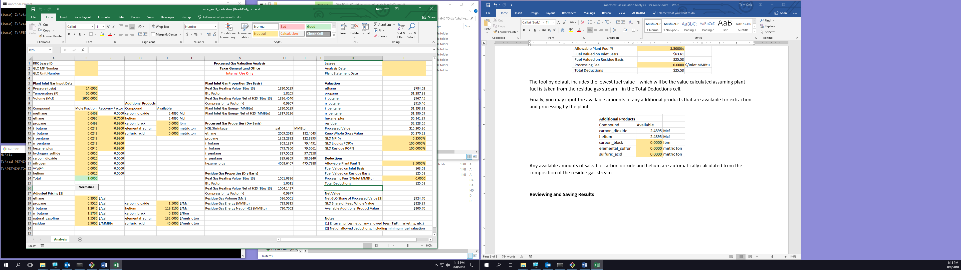

Note that all calculations performed by the tool are on a dry basis, which means that your input gas composition must also be on a dry basis, i.e. net of water.

The amount of recovered liquid volume, and the corresponding shrink energy represented by that volume, for each NGL component are available in the Processed Gas Properties section.



Residue gas properties (again, on a dry basis) are shown directly below the NGL properties.



The value of each product is shown in the Valuation section, where Processed Value represents the total value of all NGL and residue products. Keep Whole Gross Value represents the hypothetical value of the rich, inlet gas stream if, instead of being processed, were sold at the residue gas price ($/MMBtu).



The **net** **GLO share of residue gas plus all NGL products** is shown in the Net Value section. Available Additional Product Value is the value available from sale of all Additional Product amounts entered.



To save your results, press Ctrl-P and select Adobe PDF, and save the PDF file on your hard drive. Do not attempt to copy the spreadsheet, because it won’t run from any location other than O:\AUDIT_TOOLS.